**DESIGN AND ANALYSIS OF POLARIZED ANTENNA SYSTEMS**

Department of Electronics and Communication Engineering  
Date: September 16, 2025

**EXECUTIVE SUMMARY**

This report presents a comprehensive analysis of **polarized antenna** design principles, covering linear, circular, and elliptical polarization techniques for modern wireless communication systems. Polarization represents the orientation of the electric field vector in electromagnetic waves and is critical for optimizing signal reception and transmission. The analysis demonstrates that proper polarization matching can improve signal strength by **20-30 dB** while circular polarization provides superior performance in multipath and mobile environments.[1][2][3][4]

**1. INTRODUCTION**

**1.1 Background**

Antenna polarization refers to the **orientation of the electric field vector** of electromagnetic waves radiated or received by an antenna. First systematically analyzed in the early 20th century, polarization has become a fundamental parameter in modern communication systems, particularly for satellite communications, radar, and 5G networks.[1][2][3][4]

**1.2 Physical Principles**

Electromagnetic waves consist of mutually perpendicular electric and magnetic field vectors that oscillate in planes perpendicular to the direction of propagation. The **polarization is defined by the electric field vector** orientation, which determines how the antenna couples energy to and from free space. The time-varying behavior of this electric field vector creates different polarization states.[1][2][5]

**1.3 Importance in Communication Systems**

Polarization matching between transmitting and receiving antennas is **critical for optimal signal transfer**. Mismatched polarizations can result in signal loss of 20 dB or more, making polarization a key design consideration for GNSS, cellular, and satellite communication systems.[1][4][6]

**2. POLARIZATION THEORY**

**2.1 Mathematical Foundation**

The polarization state of an electromagnetic wave is mathematically described by the relationship between orthogonal electric field components **Ex** and **Ey**. The general expression for the electric field vector is:[5]

**E = Ex cos(ωt + φx) + Ey cos(ωt + φy)**

where φx and φy represent the phase relationships between components.[7][5]

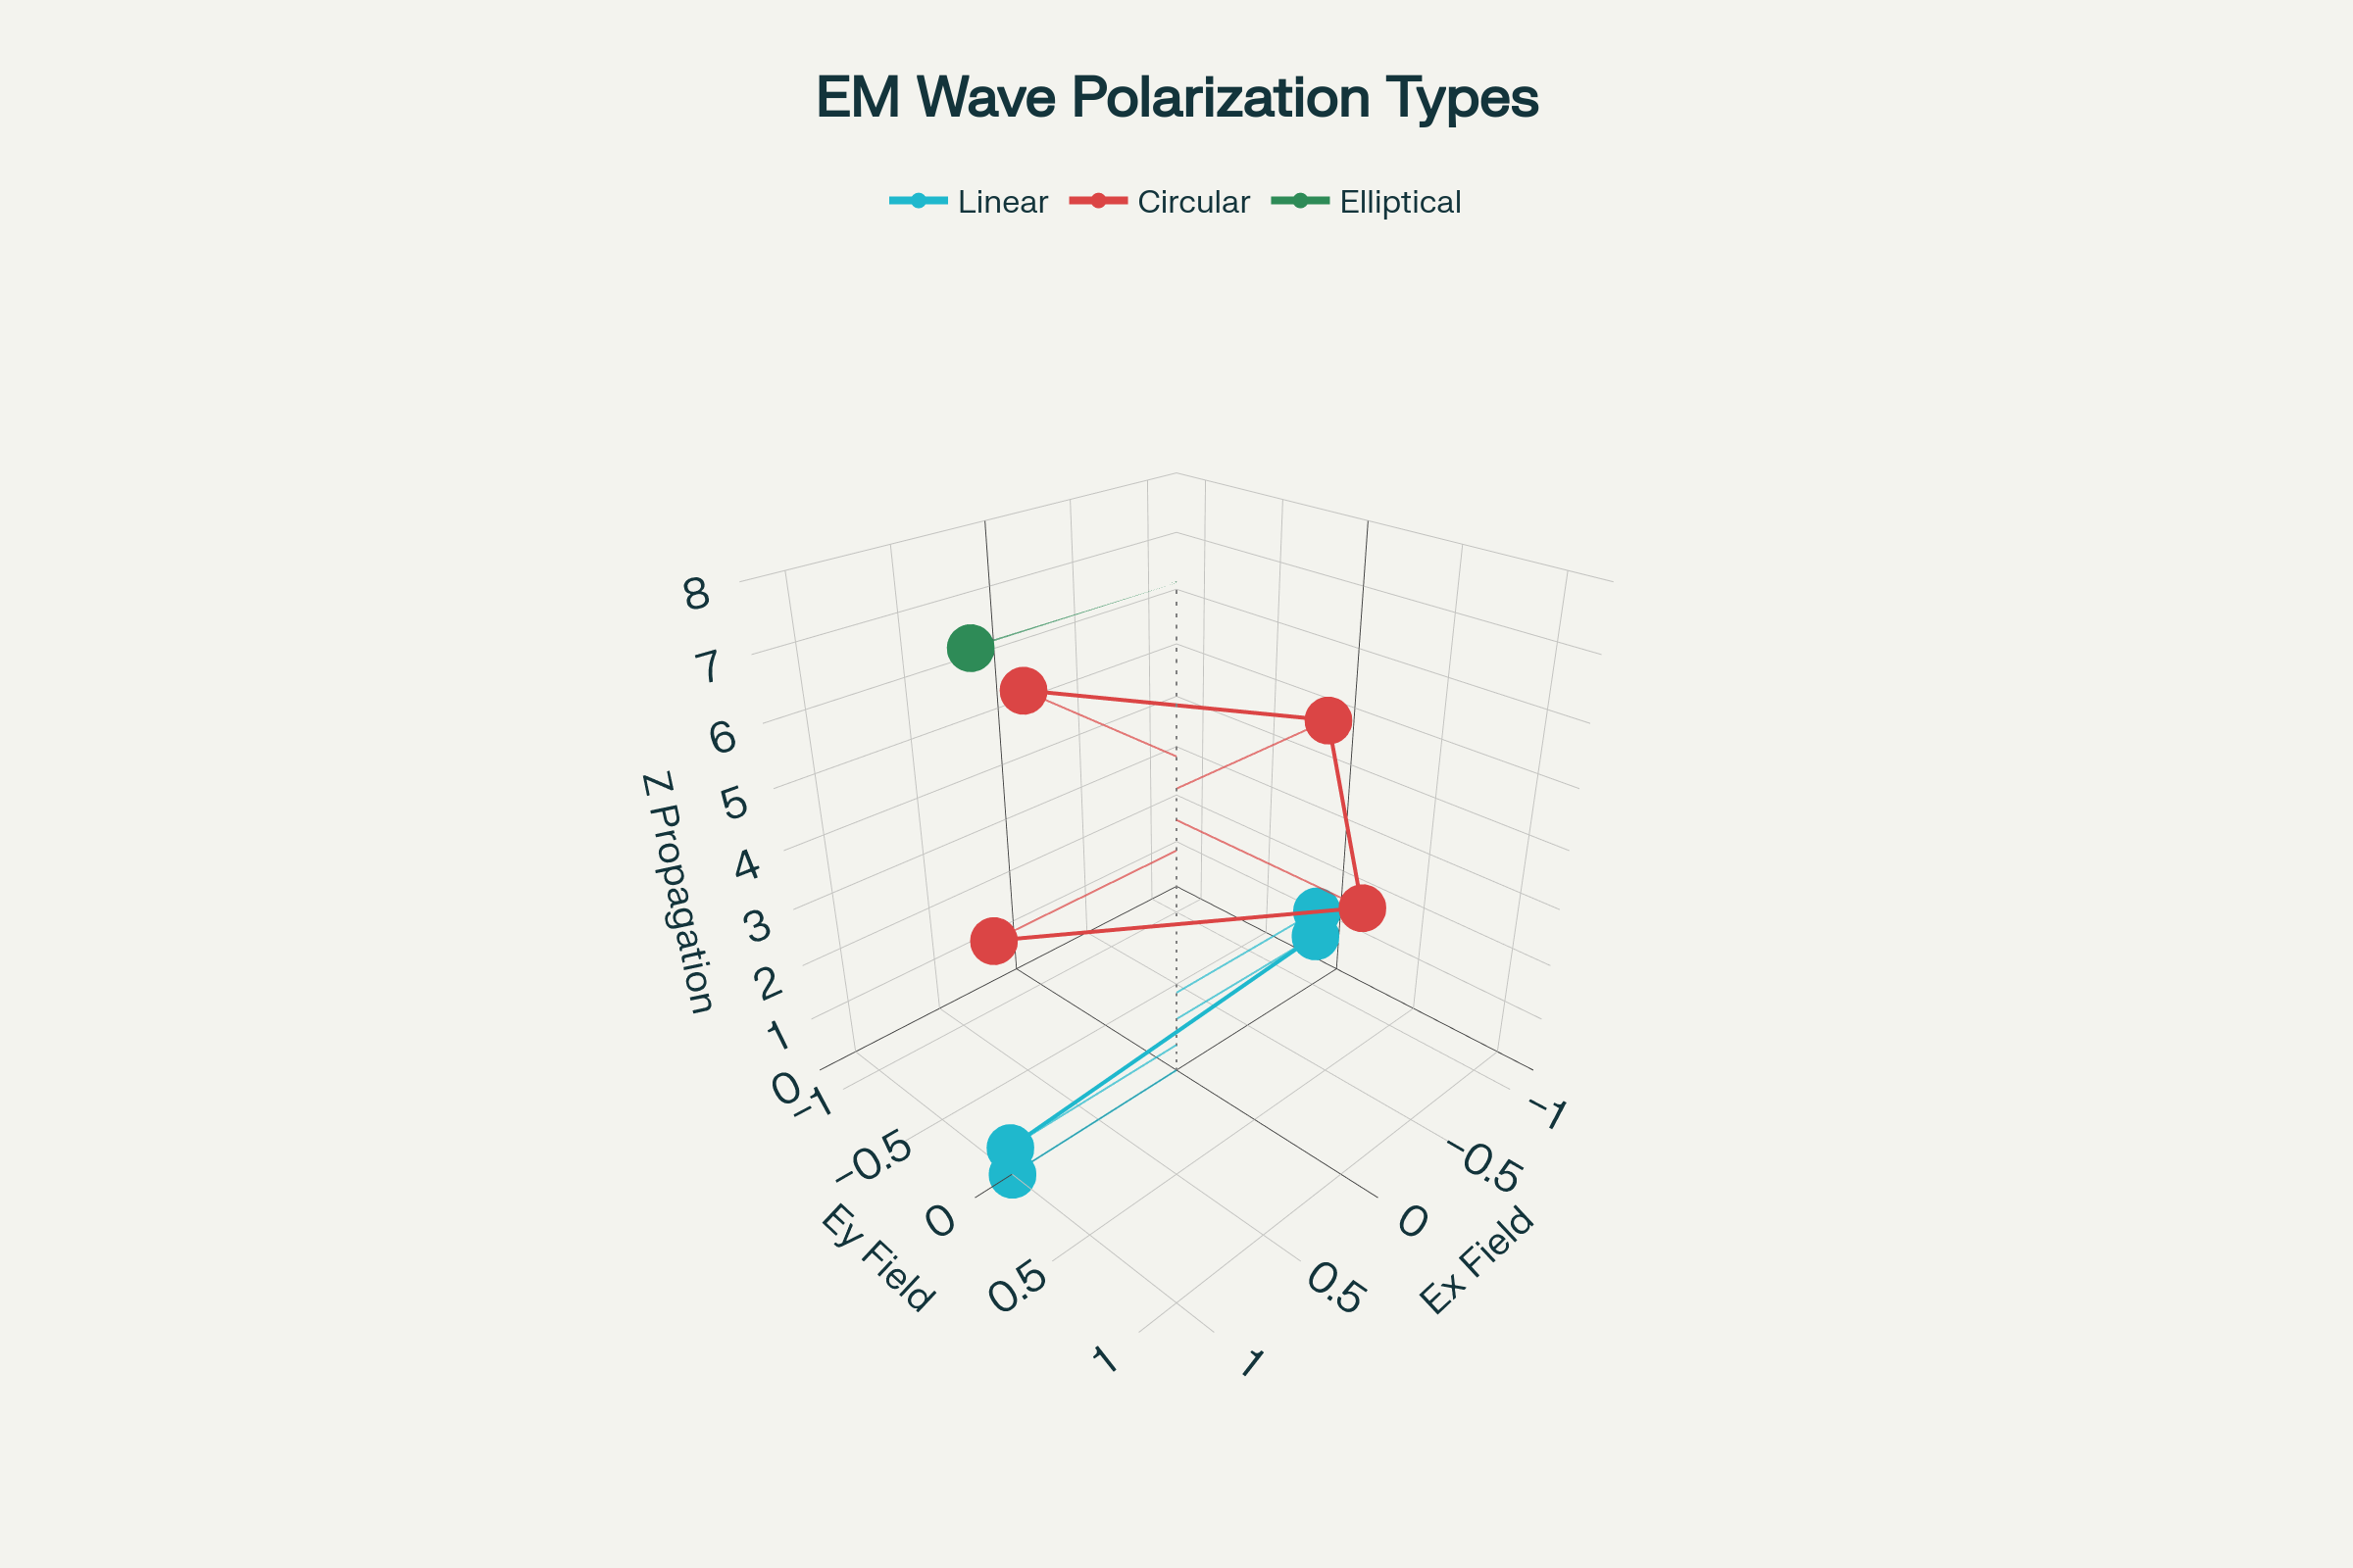

Figure 1 – Electric field vector behavior for different polarization types over one complete cycle.

**2.2 Polarization Classification**

Electromagnetic waves exhibit three primary polarization states based on the electric field vector behavior :[2][5]

* **Linear Polarization**: Electric field oscillates in a single plane
* **Circular Polarization**: Electric field rotates with constant magnitude
* **Elliptical Polarization**: Electric field traces an elliptical path

**2.3 Polarization Parameters**

Key parameters include **axial ratio** (ratio of major to minor axis), **tilt angle** (orientation of major axis), and **sense of rotation** for circular polarization. An axial ratio below 3 dB indicates good circular polarization performance.[8][9]

**3. LINEAR POLARIZATION**

**3.1 Vertical Polarization**

**Vertical linear polarization** occurs when the electric field vector oscillates perpendicular to the Earth's surface. This polarization is commonly used in AM/FM broadcasting and cellular communications due to its favorable propagation characteristics over ground.[1][2][3][10]

**3.2 Horizontal Polarization**

**Horizontal polarization** has the electric field parallel to the Earth's surface and is widely used in television broadcasting and some radar applications. However, horizontal polarization suffers from ground reflection phase reversal, which can cause signal cancellation.[1][3]

**3.3 Design Techniques**

Linear polarization is achieved through **antenna geometry alignment** - vertical elements produce vertical polarization, while horizontal elements create horizontal polarization. The antenna's physical orientation directly determines the polarization plane.[1][2]

**4. CIRCULAR POLARIZATION**

**4.1 Fundamental Principles**

Circular polarization occurs when two orthogonal electric field components have **equal magnitude and 90° phase difference**. The electric field vector rotates in a circular path, creating either Right-Hand Circular Polarization (RHCP) or Left-Hand Circular Polarization (LHCP).[7][9][5]

**4.2 Design Methods**

Common techniques for achieving circular polarization include **truncated corner patches**, **crossed dipoles with quadrature feeding**, and **helical antenna structures**. Single-feed designs use geometric perturbations to create the required orthogonal modes.[8][7][11]

**4.3 Applications**

Circular polarization is essential for **satellite communication** systems, particularly GNSS applications where signals must penetrate through atmospheric disturbances. The 3 dB circular polarization loss is acceptable given the enhanced multipath rejection and weather resistance.[3][4][6]

**5. ELLIPTICAL POLARIZATION**

**5.1 Characteristics**

Elliptical polarization represents the **general case** where the electric field vector traces an elliptical path with varying axial ratios. Most practical antennas exhibit some degree of elliptical polarization due to manufacturing tolerances and environmental effects.[2][5]

**5.2 Axial Ratio Considerations**

The **axial ratio** (AR) quantifies the ellipticity, with values approaching 1 (0 dB) indicating circular polarization and infinite values representing linear polarization. Practical circular polarization requires AR < 3 dB across the operating bandwidth.[8]

**5.3 Design Applications**

Elliptical polarization provides a **compromise** between linear and circular polarization, offering partial multipath resistance while maintaining simpler design requirements than pure circular polarization.[7]

**6. DESIGN TECHNIQUES**

**6.1 Single-Feed Circular Polarization**

**Perturbation methods** create circular polarization from single feed points by introducing asymmetries in symmetric antenna structures. Common techniques include corner truncation, diagonal slots, and reactive loading elements.[8][7][11]

**6.2 Dual-Feed Systems**

**Quadrature feeding** uses two orthogonal feeds with 90° phase difference to generate circular polarization. This approach provides better axial ratio bandwidth but requires more complex feeding networks.[11][12]

**6.3 Helical Antennas**

**Helical antennas** naturally generate circular polarization through their geometric structure, with axial mode operation providing excellent circular polarization purity. The helix diameter and pitch angle determine the polarization sense and bandwidth.[9][12]

**7. PERFORMANCE ANALYSIS**

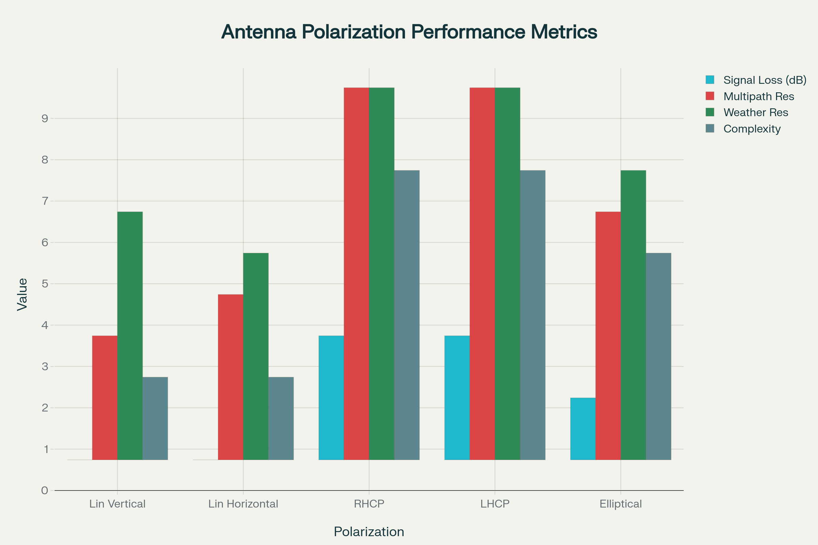

Figure 2 – Performance comparison of different antenna polarization types across key metrics.

**7.1 Signal Loss Mechanisms**

**Polarization mismatch** between transmit and receive antennas causes signal attenuation according to the cosine of the polarization angle difference. Complete cross-polarization (90° mismatch) results in theoretical infinite loss.[1][3]

**7.2 Multipath Performance**

**Circular polarization** provides superior multipath rejection because reflected signals often experience polarization inversion, reducing interference. This advantage is particularly valuable in urban environments and mobile applications.[3][4]

**7.3 Weather Effects**

**Atmospheric depolarization** affects linearly polarized signals more severely than circularly polarized ones. Rain and ice crystals cause differential phase shifts that degrade linear polarization while having minimal impact on circular polarization.[3][13]

**8. MEASUREMENT TECHNIQUES**

**8.1 Axial Ratio Measurement**

**Spinning linear method** uses a rotating linearly polarized receive antenna to measure the axial ratio of a circularly polarized antenna under test. The ratio of maximum to minimum received power indicates the axial ratio quality.[8][9]

**8.2 Polarization Pattern**

**Co-polar and cross-polar** radiation patterns quantify the antenna's polarization purity across different angles. The co-polar pattern represents the desired polarization while cross-polar indicates unwanted orthogonal components.[8]

**8.3 Phase Measurement**

**Vector network analyzers** measure the phase relationship between orthogonal field components to characterize elliptical polarization parameters. Time-domain measurements can reveal polarization variations across the antenna bandwidth.[8][11]

**9. APPLICATIONS**

**9.1 Satellite Communications**

**GNSS systems** require RHCP antennas to match satellite transmissions and minimize multipath errors. Satellite television uses dual circular polarization to double channel capacity within the same frequency band.[3][4][6][13]

**9.2 Cellular Networks**

**5G millimeter-wave** systems increasingly use dual-polarized antennas to implement MIMO techniques and improve spectral efficiency. Base stations typically employ vertical linear polarization for optimal propagation.[4][14]

**9.3 Radar Applications**

**Weather radar** uses circular polarization to discriminate between different precipitation types through differential reflectivity measurements. Target identification benefits from polarimetric radar techniques using multiple polarization states.[3]

**10. DESIGN CONSIDERATIONS**

**10.1 Bandwidth Requirements**

**Circular polarization bandwidth** is typically narrower than impedance bandwidth due to the axial ratio constraint. Wideband circular polarization requires careful optimization of perturbation elements and feeding structures.[8][7][11]

**10.2 Manufacturing Tolerances**

**Dimensional accuracy** significantly affects polarization purity, particularly for high-frequency applications. Asymmetric perturbations are sensitive to manufacturing variations, requiring tight tolerances for consistent performance.[8][11]

**10.3 Environmental Effects**

**Temperature variations** and mechanical stress can alter antenna geometry and affect polarization characteristics. Robust designs must account for environmental stability to maintain polarization performance.[2][11]

**11. EMERGING TECHNOLOGIES**

**11.1 Metamaterial Polarizers**

**Artificial electromagnetic surfaces** enable novel polarization control techniques with ultra-thin profiles. These structures can convert between polarization states or create polarization-selective surfaces.[14]

**11.2 Reconfigurable Polarization**

**Switchable polarization** antennas use PIN diodes or varactors to dynamically change polarization state. This capability enables adaptive communication systems that optimize polarization for varying channel conditions.[14]

**11.3 Multi-Polarized Arrays**

**Massive MIMO** systems employ arrays with multiple polarization states to increase channel capacity and improve spatial diversity. Advanced beamforming algorithms exploit polarization diversity for interference mitigation.[14]

**12. COMPARATIVE ANALYSIS**

|  |  |  |  |  |
| --- | --- | --- | --- | --- |
| Parameter | Linear Vertical | Linear Horizontal | Circular (RHCP/LHCP) | Elliptical |
| **Signal Loss** | 0 dB (matched) | 0 dB (matched) | 3 dB (cross-polar) | 1-3 dB |
| **Multipath Rejection** | Poor | Moderate | Excellent | Good |
| **Weather Resistance** | Moderate | Poor | Excellent | Good |
| **Design Complexity** | Simple | Simple | Complex | Moderate |
| **Bandwidth** | Wide | Wide | Narrow | Moderate |
| **Manufacturing Tolerance** | Relaxed | Relaxed | Tight | Moderate |

*Table 1: Performance comparison of different polarization types*[1][3][4]

**13. FUTURE TRENDS**

**13.1 6G Communications**

**Terahertz frequencies** will require precise polarization control for atmospheric propagation. Polarization diversity will become increasingly important for maintaining link reliability at these frequencies.[14]

**13.2 IoT Applications**

**Low-power polarized antennas** for IoT devices must balance performance with size and cost constraints. Integrated polarization control circuits will enable smart antenna systems.[4][14]

**13.3 Space Applications**

**Satellite constellations** will drive demand for wideband circular polarization antennas with improved axial ratio performance. Intersatellite links will require precise polarization alignment for optical and RF communications.[13]

**14. CONCLUSION**

Polarized antennas represent a **fundamental technology** for modern wireless communications, with circular polarization offering superior performance in challenging propagation environments despite increased design complexity. The 3 dB circular polarization loss is often justified by the significant improvements in multipath rejection and weather resistance. Future developments in metamaterials, reconfigurable designs, and multi-polarized arrays will continue to expand the capabilities of polarized antenna systems for 6G, satellite, and IoT applications.[1][3][4][14][13]

Understanding polarization theory and design techniques is essential for developing robust communication systems that maintain reliable performance across diverse operating conditions. The proper selection and implementation of antenna polarization directly impacts system performance, making it a critical consideration in modern RF design.[2][4][1]

**REFERENCES**

1. <https://www.electronics-notes.com/articles/antennas-propagation/antenna-theory/polarisation-polarization.php>

1. <https://electronicsdesk.com/antenna-polarization.html>

1. <https://en.wikipedia.org/wiki/Polarization_(waves)>

1. <https://www.siretta.com/2025/04/antenna-polarization-explained-and-why-it-could-make-or-break-your-rf-performance/>

1. <https://en.wikipedia.org/wiki/Circular_polarization>

1. <https://www.sbg-systems.com/glossary/antenna-polarization-gnss/>

1. <https://www.atlantis-press.com/article/6300.pdf>

1. <https://ictactjournals.in/paper/IJCT_Vol_11_Iss_3_Paper_5_2234_2238.pdf>

1. <https://antennatestlab.com/wp-content/uploads/2017/09/CP-Explained-Without-Math.pdf>

1. <https://www.cliffsnotes.com/study-notes/604419>

1. <http://vce.vidya.edu.in/Files/Publication/Circular-Polarization-techniques-in-Microstrip-Antennas.pdf>

1. <https://atlcllc.com/antenna-polarization-application-note/>

1. <https://anywaves.com/resources/blog/definition-whats-polarization-for-space-antennas-and-why-is-it-important/>

1. <https://www.mpantenna.com/multi-polarized-antennas-benefits/>

1. <https://jemengineering.com/blog-intro-to-antenna-polarization/>

1. <https://sist.sathyabama.ac.in/sist_coursematerial/uploads/SEC1301.pdf>

1. <https://www.sciencedirect.com/topics/engineering/polarized-antenna>

1. <https://www.uni-saarland.de/fileadmin/upload/lehrstuhl/dyczij-edlinger/Downloads/Lehre/MA/AT1/VU/ANT1_Chapter2.pdf>

1. <https://www.gmrt.ncra.tifr.res.in/doc/Lectures/01-Basics_of_Antennas.pdf>

1. <https://www.jpier.org/issues/volume.html?paper=12052304>